BECOMING MORE SIGNIFICANT
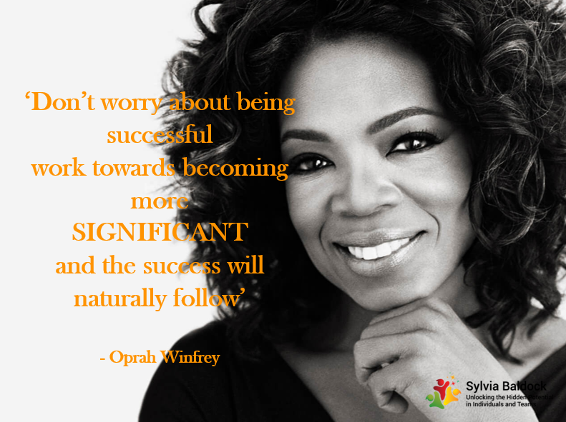
How much time and effort do you pour into nurturing your greatest asset,
namely 'YOU'?
We are often chasing deadlines, juggling multiple ‘to do’ lists, racing from one meeting to the next. Taking time to invest in our personal growth and well-being can seem self-indulgent and often goes to the bottom of that long 'to do' list or is always at the bottom and viewed as a luxury which is not really deserved!
When we are stretched, focused on hitting vital deadlines, working all the hours God sends and verging on overwhelm, we are in ‘survival’ mode. It’s like trying to run a car on an empty tank – you can keep your foot on the throttle, but you will just end up burning out the engine!
According to Cellular Biologist, Dr Bruce Lipton, the trillions of cells in our bodies are always in one of 2 operating modes –either ‘survival or growth’. There is a small ‘gateway’ in each cell through which all the nutrients in our blood stream pass to enable us to continue the thrive.
When we are stressed, we release the stress hormones, cortisol, adrenalin and norepinephrine and our cells recognise toxins in our blood stream and shut the ‘gateway’ to protect us from the damaging effect of those toxins.
This also prevents essential nutrients from passing through into our cells and explains why we become ‘sick and tired’ when under long term stress.
When we feel like this, we have nothing to give to others, so we become ‘selfish’ where even a small request, especially for our precious time, becomes a big issue.
We become short tempered, irritable, critical of self and others and people start to give us a wide berth.
We don't take the time to appreciate the key people in our life. Showing gratitude can seem like an unnecessary indulgence. They know how we feel about them, don’t they? – or do they?
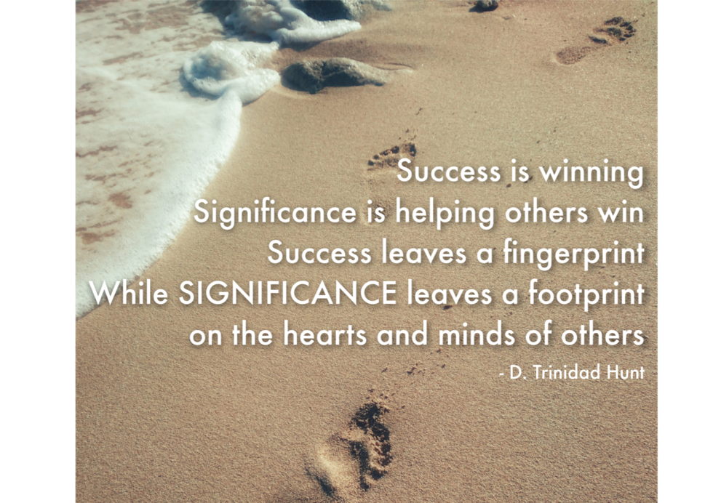
A word of thanks, praise or love, can go such a long way to making someone’s day and it may mean that they in turn, not only reciprocate but also go on to appreciate someone in their life.
So how can we be more giving to the people around us, how can we spread more love and genuine appreciation for the people we connect with every day, ‘paying it forward’ like the baton in a relay race so our warmth and gratitude go viral in the wider communities of everyone we interact with
The best way we can serve others and make them feel valued, is to nurture ourselves an become more 'SIGNIFICANT'!
Significance is all about the impact we have on others and the Legacy we 'Live' and Leave!
It comes from valuing ourselves enough to invest in our personal growth, confidence and self-esteem.
“Low self-esteem is like driving through life with your hand-break on.”– Maxwell Maltz
When we take time to rest, exercise, eat well, meditate, get out in nature, spend quality time with the people we love, we feel re-energised.
We can appreciate all that is rich and fulfilling in our lives, we feel re-charged, re-focused and ‘raring to go’.
We then work far more effectively and productively.
We become ‘selfless’ – we have time to listen to others, to give our valuable support and advice and in turn to make them feel valued.
Investing in your greatest asset – ‘YOU’, is the best investment you will ever make for both your business and your life.
Learning to nurture yourself first enables you to love and support others more and to make your own unique contribution to your community and to the world at large.
My top tips for investing in 'YOU'
1. Recognise and celebrate who you are at your core – the biggest shift I had in this was doing a personality profile in 2012 – it had a major impact on my self-belief, my vision and the actions that have led me to the life and business I absolutely love today.
Read more https://sylviabaldock.com/contribution-compass-profiles/
2. Spend 75-80% of your time fully in ‘flow’ doing the work you love and where ypu add most value.
3. Become an ‘expert’ in your field. When you know your true value, and your unique offerings, you can focus on constantly learning and growing in your specialist area so you always have something fresh to offer your clients and prospects.
You will be excited to share your knowledge and your clients will feel enriched by your offerings.
4. Be the best version of you. Regularly invest in your own spiritual and mental growth. Stretch yourself out of your comfort zone -keep pushing the boundaries.
Surprise yourself everyday by stepping up in both your business and personal life and enjoy the feeling of achievement at the end of each day.
5. Nurture yourself; knowing that the more you do this on a regular basis, the more you can nurture others. Eat healthy nutritious meals, get to bed early and enjoy the rejuvenating impact of those sleep hours before midnight. Take regular breaks throughout the day, exercise, meditate, get out in nature, – do whatever makes you feel refreshed and re-charged.
You are subliminally saying ‘I matter’
6. Spend time with inspirational people who will support and encourage you to keep evolving and stretching out of your comfort zone. Their energy will fire you up and your energy will in turn inspire others. Regularly tune into Ted talks, webinars and videos to boost your understanding and motivation.
7. Invest in your appearance. The better you feel you look, the more confident you will feel and the more ready you will be to interact with and give value to others.
Invest in a colour and image consultation and find the shades and styles that are right for you and your unique skin tone. This is an investment for life and means you will have a wardrobe full of clothes that you actually wear and feel fabulous in – (most of us wear 20% of our wardrobe 80% of the time). It will also save you a huge amount of shopping time and a small fortune, as you will only buy clothes that suit you and that you will then wear.
8. Regularly spend time with the key people in your life – your family and good friends. Arrange fun days out or simple gatherings at home where you can just relax and share good food, great company, love and laughter. This releases the wonderful 'feel-good' hormone of attachment - 'Oxytocin', which raises our mood and engenders feelings of gratitude and generosity.
They are the people who just want your company more than anything. They remind you why you do what you do and the more love and attention you give them, the more you will receive in return – ‘what goes around comes around,’
9. Wherever you are, be totally ‘PRESENT’, give the gift of undiluted listening and leave people feeling heard and valued.
A favourite quote of mine –
‘People who recognise and celebrate their uniqueness exude a magnetic energy that is totally irresistible.’
As I learn to nurture myself more each day and to share my unique value with the world, I am finding people are drawn to work with me even though they may not know why.
So, start learning to love yourself unconditionally and invest in your greatest asset – it is not selfish, it is the opposite, it makes you selfless and instantly expands your capacity to love and support those around you.
“Self-care is never a selfish act—it is simply good stewardship of the only gift I have, the gift I was put on earth to offer to others.”
– Parker Palmer
SPECIAL OFFERS DURING COVID-19 LOCKDOWN
BECOMING MORE SIGNIFICANT
Transformational 6week online programme which includes the Contribution Compass profile and a full explanation of how to use the knowledge
JUST £297+VAT
https://sylviabaldock.com/covid-19-special-offer/

CONTRIBUTION COMPASS profile test £50 - BUY Here

In depth debrief session on how to apply the learnings - just £57+VAT - Buy Here
YOU SAVE £150 (Normal price profile +debrief £257)

Sylvia Baldock
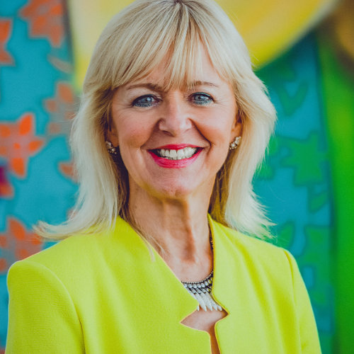
Maximising Personal and Team Talent, Team Engagement & Collaboration Specialist, Personal Impact Thought Leader, Professional Speaker & Presentation Skills Expert, Business/Personal Coach/Mentor, ‘Time to Think’ Facilitator, Author and Best-selling International Co-Author,
Sylvia enables Business Leaders, Teams and Entrepreneurs to recognise the unique value they bring to the workplace and to lead with confidence and purpose. Sylvia pinpoints your natural strengths and challenges and works with you to ensure you are playing to those strengths 70-80% of your working time.
When you are using your particular skill set, you consistently deliver at a very high standard, you become increasingly creative in your specialist area and you solve problems like never before.
You become recognised as a trusted 'expert' and the ‘go to’ person and in your field.
Sylvia also acts as a powerful catalyst for maximising the talent in your organisation. Her workshops utilise impactful profiling to identify how to harness the real value each team member has to offer. This generates frank and open discussion and results in a collaborative culture where your people value their differences, tap into each other’s strengths and become more engaged, motivated, productive and profitable.

Sylvia has extensive experience working with Business leaders, CEO groups, Senior Managers, Senior Women, Entrepreneurs, Charities and Social Enterprises, SMEs, CIMA, AAT and NHS supply teams.

Sylvia regularly speaks and runs Masterclasses on the following –
- Becoming Significant
Harness your unique value and operate with confidence and purpose
- Creating Collaborative Teams
Catalyse the Natural Talents of Your Team
- Power Up Your Personal Impact
- Present with Power, Passion and Presence
- Building a Powerful Network

Qualifications and Experience
Neuroscience Personal Development accredited
Professional Speakers Association Professional Member
Executive Coach (The Coaching Academy)
‘Time to Think’ Coach
Harmonizing Alignment Consultant
Authentic Charisma Coach
NLP Diploma,
Association of Coaching member

Sylvia Baldock 07909 914815

sylvia@sylviabaldock.com
http://www.sylviabaldock.com
http://www.facebook.com/sylvia.baldock
http://twitter.com/Sylviabaldock
https://www.linkedin.com/in/sylviabaldock
http://www.youtube.com/user/sylviabaldock

